

**Firmware Team**

**Bootloader简介**

**Beken Corp**

目录

bk_bootloader repo 3

Branch Information 3

Current MP Boot-loader Version 5

# bk_bootloader repo

## Branch Information

http://192.168.0.6/wangzhilei/bk_bootloader.git

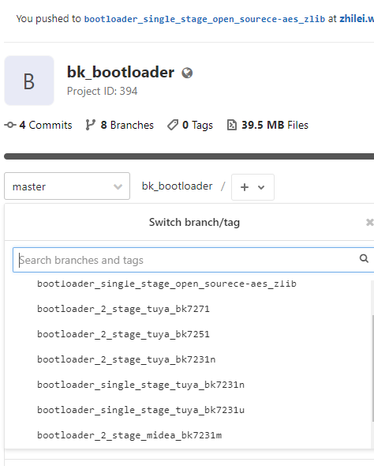  
  
2021-10-19 19:29 tuya two-stage bootloader bk7271   
    源分支信息：http://192.168.0.6/wifi/rtt_bootloader/-/commits/tuya_bk7271_boot_2_stage commit id: 0fe08a2d7f77bc9d8cfa8a28ba26a7287860396b  
  
2021-10-19 19:29 tuya two-stage bootloader bk7251   
    源分支信息：http://192.168.0.6/wifi/rtt_bootloader/-/commits/tuya_bk7251_boot_2_stage commit id: d302ee3e5cd4d6820eee34782bfed9c65653a715  
      
2021-10-19 19:29 tuya two-stage bootloader bk7231n   
    源分支信息：http://192.168.0.6/wifi/rtt_bootloader/-/commits/tuya_bk7231N_boot_2_stage commit id: 726aa65825e89ce37814e2f2c81bd7a62b1fc764  
      
2021-10-19 19:27 tuya single-stage bootloader bk7231n   
    源分支信息：http://192.168.0.6/wifi/rtt_bootloader/-/commits/tuya_freertos_bk7231N commit id：736167a0a2400969087942d297e292553a788ca1  
      
2021-10-19 19:22 tuya single-stage bootloader bk7231u   
    current version: 1.0.6  
    源分支信息：http://192.168.0.6/wifi/rtt_bootloader/-/commits/tuya_freertos commit id: 983d7f49a3089f89a9158366c896730d43a057fa  
  
2021-10-19 19:13 midea two-stage bootloader bk7231m branch  
    bootloader no log output;  
    源分支信息:http://192.168.0.6/wifi/rtt_bootloader/-/commits/midea_bk7231m commit id：e406df2e588d8b58e1487cb2541ee4786247df05  
  
2010-10-19 17:39 master two-stage bootloader branch  
    3.1.x/3.0.x release sdk都使用这个bootloader。  
    tips:  
    a, 这个工程是两级bootloader：lower bootloader、upper bootloader；暂时采用armcc/mdk/keil编译；  
    b, soc（bk7231u/bk7231n/bk7251/bk7271）切换需要更改CFG_SOC_NAME（up_boot\system\bk_config.h和l_boot\system\bk_config.h）和对应的scatter files（链接脚本）；  
    c, 源分支信息：http://192.168.0.6/wifi/rtt_bootloader/-/commits/master， commit id： abab852df100472585034388262ea8b5ddbbcf89；  
    d, and so on;  
  
2021-10-19 current bootloader status  
    wifi bootloader： http://192.168.0.6/wifi/rtt_bootloader.git，细节如下：  
        主线sdk的bootloader分支：master  
        Midea 7231M分支：midea_bk7231m  
        tuya 7231u: tuya_freertos  
        tuya bk7231N: tuya_freertos_bk7231N  
        tuya bk7271两级：tuya_bk7271_boot_2_stage  
        tuya bk7251两级：tuya_bk7251_boot_2_stage  
        tuya bk7231N两级：tuya_bk7231N_boot_2_stage

## Current MP Boot-loader Version

1. tuya 7231u: tuya_freertos

涂鸦bk7231u量产最后版本号BK7231S_1.0.6，commit id：983d7f49

1. tuya bk7231N: tuya_freertos_bk7231N

tuya bk7231N量产最后版本号BK7231N_1.0.1，commit id：736167a0

1. Midea 7231M分支：midea_bk7231m

midea bk7231M量产最后版本号BK7231M_1.0.8, commit id: e406df2e